BookFlow Library Management System – Week 1
Name: Pranavi
Roll No: 2520030050
Course: Database System Engineering and Distributed Backend Development
1. Login to MySQL
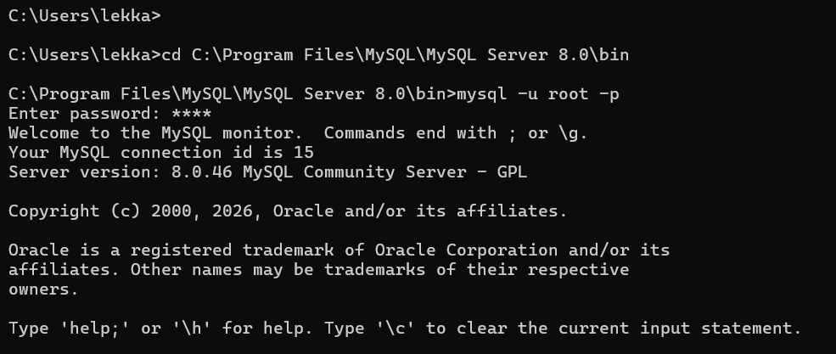2. Create Database
mysql> show databases;
+--------------------+
| Database |
+--------------------+
| bookflow_db |
| information_schema |
| mysql |
| performance_schema |
| studentdb1 |
| sys |
+--------------------+
6 rows in set (0.00 sec)

mysql> create database if not exists bookflow_db;
Query OK, 1 row affected, 1 warning (0.00 sec)

mysql> use bookflow_db;
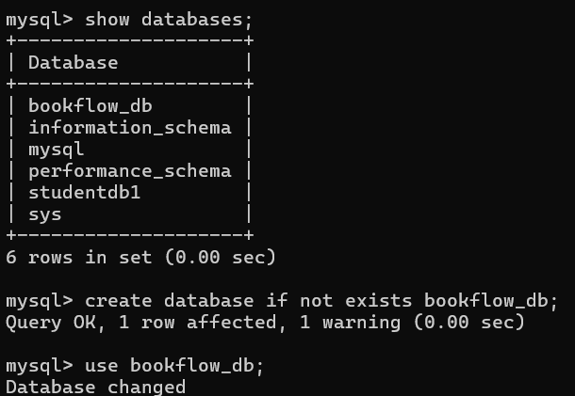
3. Create books Table
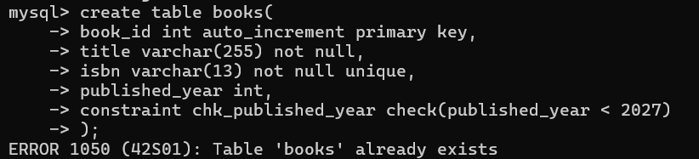
4. Create members Table
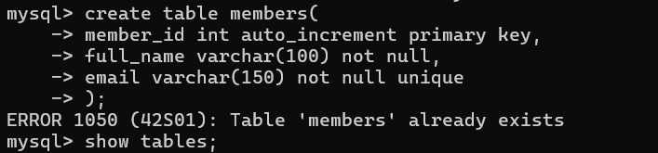
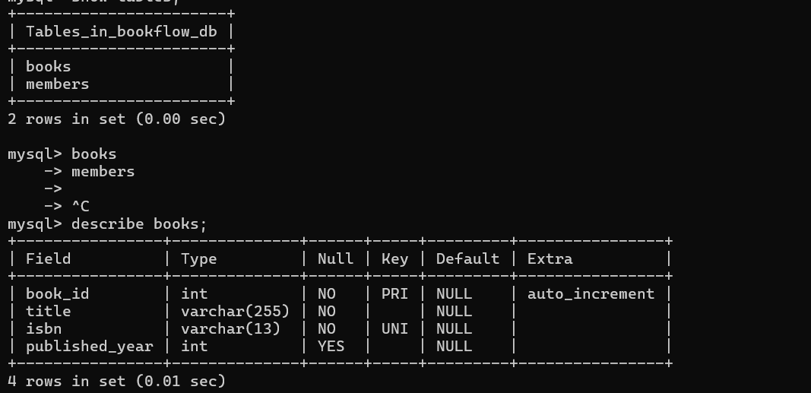
5. Insert Data
mysql> insert into books(title,isbn,published_year)
-> values
-> ('Java Programming','9780132350884',2020),
-> ('Python Basics','9780735211292',2021),
-> ('Database Systems','9780061122415',2019);
ERROR 1062 (23000): Duplicate entry '9780132350884' for key 'books.isbn'
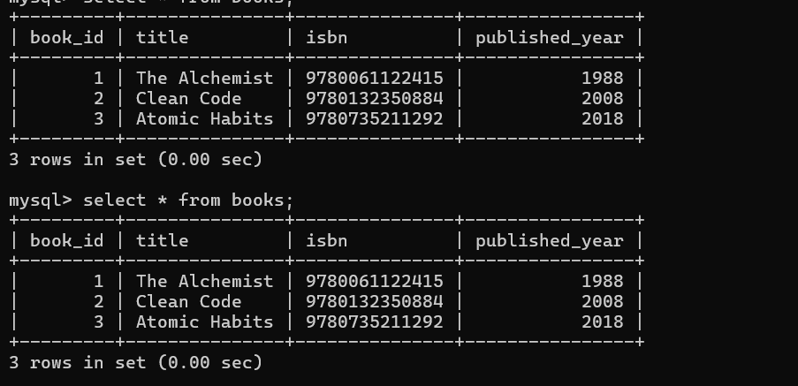
mysql> insert into members(full_name,email)
-> values
-> ('Pranavi','pranavi@gmail.com'),
-> ('Samanvitha','samanvitha@gmail.com'),
-> ('Saranya','saranya@gmail.com');
Query OK, 3 rows affected (0.03 sec)
Records: 3 Duplicates: 0 Warnings: 0
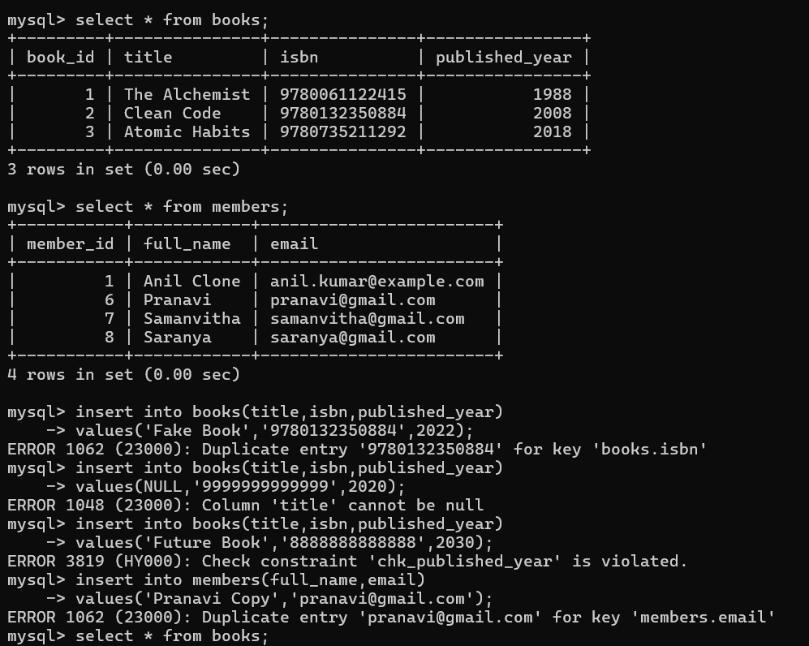
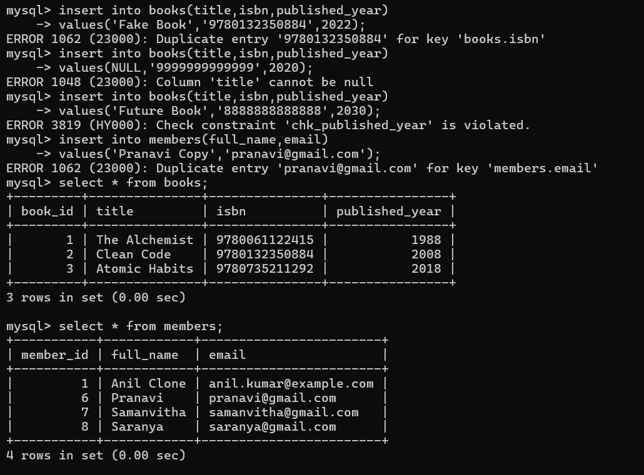

mysql> insert into members(full_name,email)
-> values('Harshitha','harshitha@gmail.com');
Query OK, 1 row affected (0.03 sec)

mysql> insert into members(full_name,email)
-> values('Nikhitha','nikhitha@gmail.com');
Query OK, 1 row affected (0.03 sec)

mysql> insert into members(full_name,email)
-> values('Yashwanth','yashwanth@gmail.com');
Query OK, 1 row affected (0.03 sec)

mysql> insert into members(full_name,email)
-> values('Sohith','sohith@gmail.com');
Query OK, 1 row affected (0.01 sec)
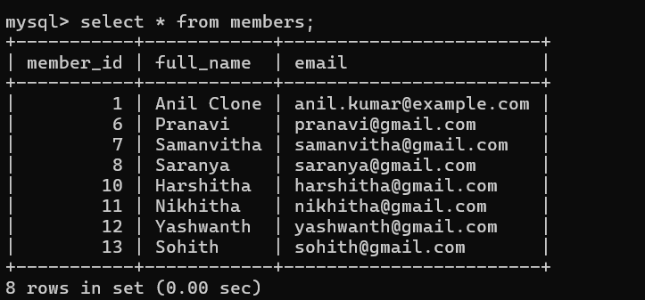
8. Conclusion
The BookFlow database was created successfully. The required tables were created, sample data was inserted, and constraints were verified successfully.

